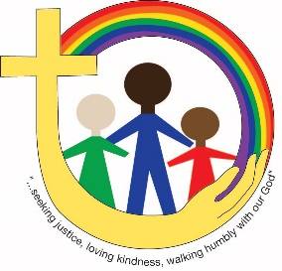
Children, Youth & Family Ministries
Duncan United Church
Sunday Journey 2019-2020
Family Name _________________________

Accompanying Adult(s) :_____________________________ Relationship:____________________________

Address:_________________________________________ Phone Number:__________________________
_________________________________________ Email:__________________________________
1st Child’s Name: ______________________ 2nd Child’s Name:__________________________
Date of Birth:__________________________ Date of Birth:_____________________________
Grade & School:_______________________ Grade & School:___________________________
Allergies:_____________________________ Allergies:_________________________________
3rd Child’s Name:______________________ 4th Child’s Name:___________________________
Date of Birth:__________________________ Date of Birth:______________________________
Grade & School:_______________________ Grade & School:___________________________
Allergies:_____________________________ Allergies:_________________________________
GUARDIAN'S PERMISSION: I declare that ____________________’s health is suitable for church- related
activities and programs. I agree to not hold staff or volunteers of Duncan United Church liable for accidents or misfortune that may occur (knowing that every precaution shall be taken by staff and/or volunteers to ensure the welfare and safety of children and youth). I also agree that photographs (without name) of this youth may be used in promotional materials of Duncan United Church and shared with others, including on the church’s website and Facebook page. Further I agree that this youth's address, number and email address will be added to the church rolls for communication purposes.

□ Please check box if you DO NOT want pictures of your child or youth to be used by Duncan United Church for promotional purposes.
Any other comments or concerns (please use back of page if more space is required): ________________________________________________________________________________________
Date: __________________________________
Guardian's Address (including postal code) _____________________________________________________________
Guardian's Name (please print clearly) _________________________________________________________________
Guardian's Signature____________________________________
(If youth is under the age of 18)
For more information, or to unsubscribe from our email list at any time, please contact Sarah Prestwich at sarah@duncanunited.org or (250) 746-6043.

