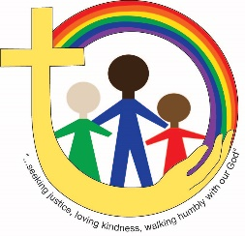
Youth Ministries
Duncan United Church
Youth Groups 2019-2020

Name: ____________________________________________
Date of Birth:________________________________________
Grade and School:___________________________________
Address (incl. Postal Code):____________________________
___________________________________________
Phone Number: _____________________________________
Email Address: ____________________________________________________
Email, Facebook and Twitter will be used to send weekly information regarding youth group activities throughout the school year. For more information, or to unsubscribe from our email list at any time, please contact Sarah Prestwich at sarah@duncanunited.org or (250) 746-6043.
Parent(s)/guardian(s) name(s):

____________________________________________
____________________________

Alternate phone number(s):

____________________________________________
____________________________

Alternate email address(es) if desired:

____________________________________________
____________________________

NOTE: PLEASE FILL OUT BACK SIDE OF FORM. THANK YOU!

