Duncan United Church
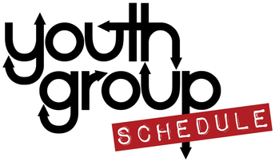

Fall 2018
- Sept. 14th, 2018 (Friday)
  - Youth Group Kick-Off Party
    - Come on down and join us for our annual Kick-off Party for the start of the Youth Group year! We will have games, snacks, and catch-up time! Bring a friend to Youth Group!
    - Junior Youth & Senior Youth together (7:00-8:30pm)
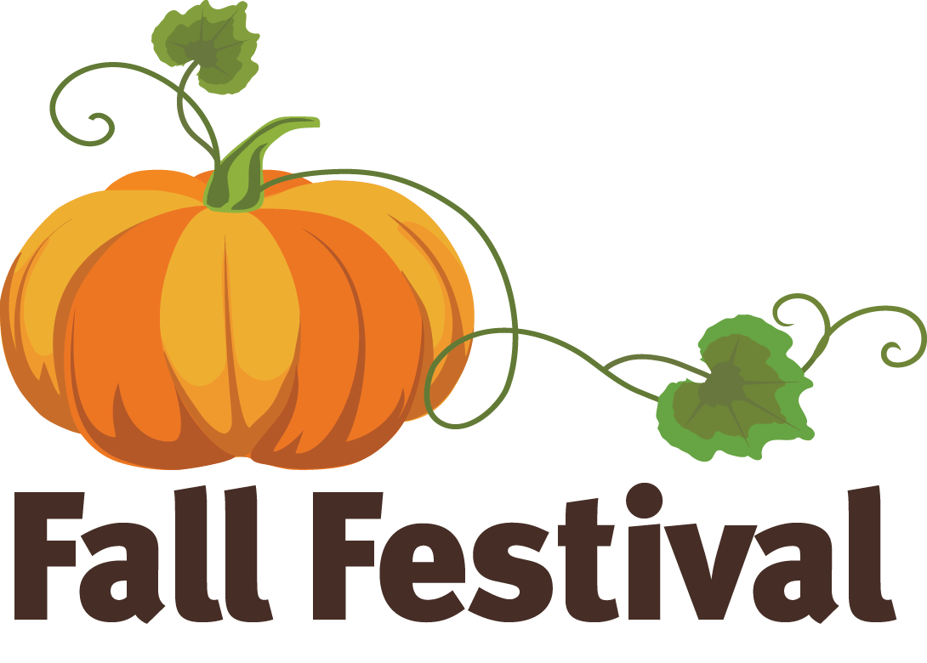

- Sept. 22nd, 2018 (Saturday)
  - Harvest Fair (Volunteering!)
    - We will be running the Kids Activity Tent at Duncan United Church’s annual “Harvest Fair”.
    - Both Junior & Senior Youth together from 9:00am-12:00pm

- Sept. 28th, 2018 (Friday)
  - Classic Youth Group Games & Bring a Friend Night!
    - This is an opportunity to bring your friends and neighbours to Youth group here at Duncan United! We will be taking part in some classic Youth Group games and delicious snacks!
    - Junior Youth – 6:00-7:00pm & Senior Youth – 7:30-8:30pm (with our shared meal together from 7:00-7:30pm)
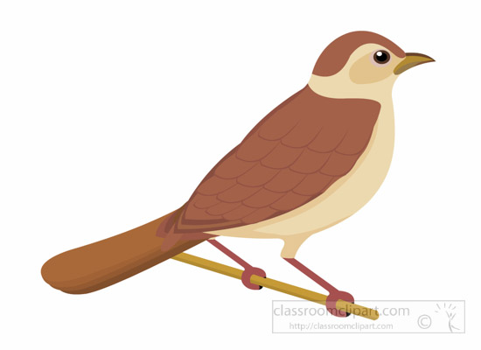
- Oct. 6th, 2018 (Saturday)
  - Trip to the Raptor Centre!
    - We will be going for an awesome time at the Raptor Centre where we will get a tour of their facilities and a flying demonstration!
    - Meet in their parking lot at 10:30am with pickup at 12:30pm (bring a packed lunch as well)
    - Cost: TBA

- Oct. 12th, 2018 (Friday)
  - Youth Group Dinner Fundraiser
    - We will be serving up a delicious meal to the congregation and the community to help raise money for our Youth Group adventures. Come on down to serve and cook this delicious meal consisting of Pancakes, bacon, hash browns and much more!
    - Arrive at 4:30pm and finish at 6:30pm (Dinner served at 5:00pm)
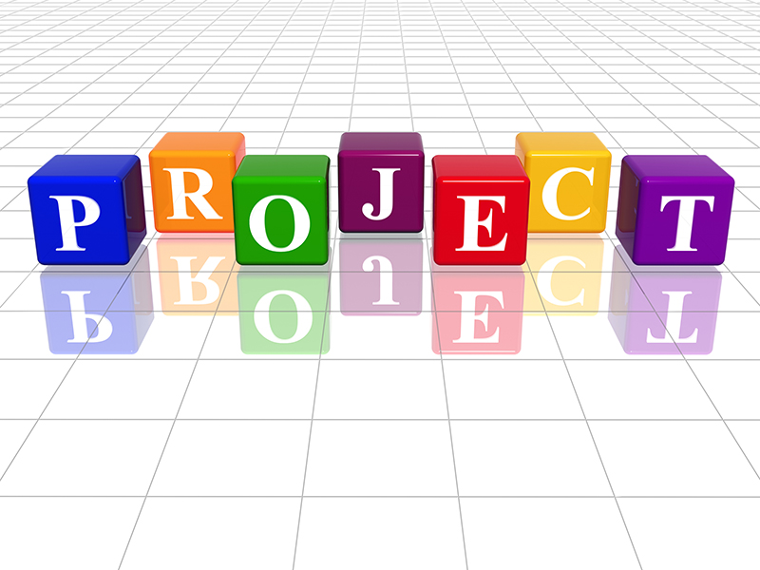
- Oct. 20th, 2018 (Saturday)
  - Camp Pringle Work Project!
    - We will be going to Camp Pringle for a day of fun and service to one of our favourite places! Come on out and help us beautify this amazing place!
    - Both Junior & Senior Youth together
    - Time: TBA
- Oct. 26th, 2018 (Friday)
  - “Pumpkin Party”
    - Come on down and join us for a night filled with everything to do with Pumpkins! We’re going overboard with the pumpkins tonight! We all must wear only orange and green!
    - Junior & Senior Youth
    - 7:00-8:30pm
- Nov. 2nd, 2018 (Friday)
  - Cooking-baking Bonanza!!
    - Join us for a frenzy of cookie-baking for the different ministries of Duncan United Church! Get ready to get cooking!!
    - Junior Youth – 6:00-7:00pm & Senior Youth – 7:30-8:30pm (with our shared meal together from 7:00 to 7:30pm)

- Nov. 9th – 12th , 2018 (Friday to Monday)
  - Evolve Conference at Stillwood Centre
    - Our annual trek to Chilliwack for the amazing Evolve Conference where we gather for friendship, community, worship, and learning.
    - This is an annual Youth Conference for those in Grades 7 & up and it is put on by BC Conference.
    - Registration online at www.evolveucc.ca
    - Financial assistance info: please talk to Sarah!
- Nov. 16th, 2018 (Friday)
  - Bowling at Duncan Bowling Lanes
    - A classic for DUC Youth Group, come and join us for a game of Bowling at our local Duncan Lanes.
    - Cost: $5.00 (includes shoe rental)
    - We will meet at the Duncan Bowling Lanes at 7:00pm and pickup at 8:30pm

- Nov. 23rd, 2018 (Friday)
  - Making Care Packages for People of our Community
    - Come on down and join us as we make some care packages for people in Duncan who need some extra love and care!
    - Junior Youth – 6:00-7:00pm & Senior Youth – 7:30-8:30pm (with our shared meal together from 7:00-7:30pm)
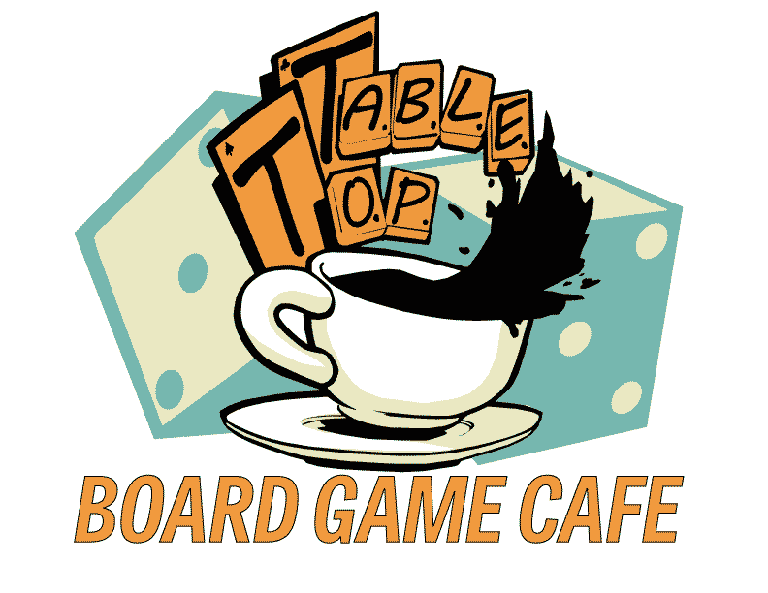

- Nov. 30th, 2018 (Friday)
  - Board Game Café
    - Come on down and join us for an intergenerational event with people from DUC and the Youth Group as we join together to have fun with board games and lots of delicious food and snacks!
    - Both Junior and Senior Youth together from 7:00-8:30pm

- Dec. 7th, 2018 (Friday)
  - Christmas at the BC Forest Discovery Centre
    - Come join us as we travel into the season of Christmas at the Forest Discovery Centre for all things Christmas and festive!
    - We will meet at the entrance of the centre at 7:00pm and pickup is at 9:00pm.
    - Cost: $10.00 per Youth

- Dec. 14th, 2018 (Friday)
  - Youth Group Christmas Party
    - We will be celebrating Christmas in style with lots of fun games, a gift exchange, and delicious snacks!
    - Both Junior & Senior Youth together from 7:00-8:30pm

